Software Development Major Project Proposal 2022

Oscar Reinitz

# Defining the problem

Within the game Counter-Strike: Global Offensive (CS:GO) there exists a “lootbox” system where players pay real money for a case and a key to roll for a random item contained within, with the potential of receiving a rare item worth lots of money on the in-game marketplace called the “Steam Market” or external sites such as “Skinport” or “Skinbaron” which allow for users to cash out their items for real money by selling them to other players or the marketplace itself. This system presents the curiosity, if one were to have a large sum of money, how profitable would gambling it on CS:GO be? Which choice of case is most profitable long term? However, there is no capability within the game to simulate such an experience without the risk of spending copious amounts of your own money. My solution was to create a price accurate simulation of the case opening system within CS:GO, allowing users to purchase cases and sell items much alike to the game, without the aspect of spending actual money.

The idea comprises a website that simulates the case opening and item system in the game Counter Strike: Global Offensive (CS:GO). The simulation would provide the user with a choice for their starting amount of money and allow them to purchase cases much like within the game. A case has a range of potential items contained within with varying value attached to each item, when a case is rolled a single item from within its contents is received. The odds of receiving each item in the case will be provided to the user, higher rarity items such as “Souvenir Weapons”, “Knives” or “Gloves” will have much higher value than other items. The simulation will allow the user to sell the items they receive to increase their balance and open more cases. Each case will have a different price depending on the rarity of the items within and the age of the case itself, as well as an accurate average market price for each item which will be scraped from an active source each time the site is loaded. The system will track the users wins and losses on case openings and allow them to look at their statistics once they either choose to end the simulation or run themselves completely out of money.

# Objectives and design specifications

## Objectives

* To create a game accurate case opening system
* Having price accurate items are updated automatically
* Progress storage of inventory items and balance
* Gain/loss statistics tracking for evaluation post simulation

## Design Specifications

The main feature objective of the software is to provide a price accurate simulation, with the value of cases and items pegged to the current average prices for the item from online marketplaces. The aim is to utilise an API from the site “CS:GO Backpack” which provides average price data as JSON objects for all market items from the last 24 hours, week, and all time, updated every 8 hours. The software will fetch the price list upon start-up and store within the local storage of the browser, a feature will exist to refresh the stored price list after it is considered out of date.

The software will include many features, the most prominent being a price accurate simulation of the case opening system in CS:GO. This requires a method to retrieve current price data, matching the case opening odds to the odds within the game and tracking of case costs and value of winnings to calculate statistics post simulation.

* Price Fetch Component
  + Function to retrieve price list from “CS:GO Backpack” API
  + Ability to store and update price list in browser storage
  + Display current price of won items
  + Function to indicate once the price list has become out of date and requires refreshing
* Case Opening Component
  + Match the odds of receiving items to CS:GO case odds
  + Create a visually appealing interface that simulates the animation of opening a case in CS:GO
  + Dynamic selection screen for the assortment of cases the user is able to open
* Statistic Logging Component
  + Track win/loss
  + Allow user to stop simulation at a desired point and generate their statistics report
* Inventory Component
  + Store “unboxed” items in browser storage
  + Allow items to be sold to increase balance
  + Store balance within browser storage

### Cases to be included in the Simulation:

Note:

* During gameplay CS:GO will occasionally reward or “drop” cases or packages to players at the end of a game. This is a major source of rare cases and specifically one of the only sources of “Souvenir Packages” which will “drop” during CS:GO eSports Majors. Due to the nature of this system older “Souvenir Packages” are in limited supply as they physically cannot “drop” anymore. As a result, the supply of many Package types has been completely extinguished, therefore it was decided to not include the “souvenir packages” within the simulation, limiting it to just weapon cases.

Base game Cases:

* Dreams & Nightmares Case
* Snakebite Case
* Fracture Case
* Prisma 2 Case
* CS20 Case
* Prisma Case
* Danger Zone
* Horizon Case
* Clutch Case
* Spectrum 2 Case
* Spectrum Case
* Glove Case
* Gamma 2 Case
* Gamma Case
* Chroma 3 Case
* Revolver Case
* Shadow Case
* Chroma 2 Case
* Chroma Case
* Huntsman Weapon Case
* CS:GO Weapon Case 3
* Winter Offensive Weapon Case
* CS:GO Weapon Case 2
* CS:GO Weapon Case

Operation Cases:

* Operation Bravo Case
* Operation Phoenix Weapon Case
* Operation Vanguard Weapon Case
* Falchion Case
* Operation Wildfire Case
* Operation Hydra Case
* Shattered Web Case
* Operation Broken Fang Case
* Operation Riptide Case

Esports Cases:

* eSports 2014 Summer Case
* eSports 2013 Winter Case
* eSports 2013 Case

# Needs of the client and Issues relevant to the solution

The client requires the simulation to be price accurate and akin to the case opening system within Counter Strike: Global Offensive. The system should be intuitive to use for both players of CS:GO and those new to the type of system, requiring minimal time to become used to the system through integration of a tooltip system.

This proposes a selection of issues related to the needs of the client:

* The design of the CS:GO system is extremely complex and rendered within a game engine, great minimalization must be undergone in the porting of a similar design over to the simulation.
* The intuitiveness of the tooltip system must be considered in design and be inclusive to a range of users with differing ability. Tooltips must be written in a form which isn’t overwhelming yet doesn’t lack in detail.
* The ergonomics of operating the site must be considered when designing the system, matching its operation closely to CS:GO to provide a similar experience which is usable for extended periods of time. This could be accomplished via the simplicity of the site design, being uncluttered and minimalistic as to not overwhelm the user during extensive usage.

The developer also experiences a list of issues related to the project’s implementation and sustainment post-development:

* The project will heavily utilise an API and database from a third-party which will require research and experience in order to implement smoothly into the system.
* Similar sites such as this do exist however often involve actual money and offer cases not provided within the game, the purpose of these sites is akin to actually gambling, the developer must distance the simulation in design from sites such as these and make it clear no affiliation exists. The system is purely a simulation and involves no monetary risk whatsoever, this must be communicated to users and in documentation to ensure the client’s needs are met.
* The system may have a limited lifespan as it depends on an API from a third-party for the price data, there is no way to ensure this API is upkept for an indefinite amount of time. As a result, when the system is maintained, this must be monitored closely to keep the site operational for as long as possible.

# General discussion of interface design and interaction with user

Due to the nature of the simulation having to emulate the case opening system from within Counter Strike: Global Offensive the user interface defines the visual appeal and usability of the system to its users. The interface is core to an intuitive user experience and should be designed with the appeal of the CS:GO fanbase in mind, while still catering to users unfamiliar with such a system. The site should operate as a single HTML page to ensure a fluid experience without requiring multiple tabs or loading of new pages, this can be achieved by using the following elements when designing the website:

* Heavy usage of HTML DIVs to conceal parts of the page and create a dynamic and fluid experience within a single HTML file.
* Large, colour contrasting buttons, clearly visible on the page in ergonomically placed areas
* Text font and size is legible in at least 14pt, colour is contrasting and does not blend in on page
* Minimalistic page design to enforce ease of use, simple colour scheme and uncluttered placement of elements on the page.
* Tooltips available for each section of the system.
* On page load the CS:GO backpack API will retrieve the price database
* System opens with a starting screen to select starting balance for simulation.
* Minimalist design of the case selection screen, presenting each case within a boxed area containing its cost, icon, and name.
  + When a case is clicked on it should enlarge, hiding all other cases and allowing the user to proceed with opening the case or exit back to the selection screen.
    - An attempt to animate the rolling of an item within the case will be made although depending on constraints this may prove difficult to achieve
  + The enlarged case screen will provide a list of the available items and a button to let the user purchase and roll the case
* Header which displays the active balance of the user, a button to end the simulation and a button to open the inventory.
  + When the inventory button is pressed it will hide the whatever is active on screen and display the inventory DIV
    - The inventory will display all collected items and allow the user to sell them
  + When the simulation is ended all DIVs will hide except the end screen and the results of the simulation will be displayed to the user, presenting them a button to reset and return to the home screen.

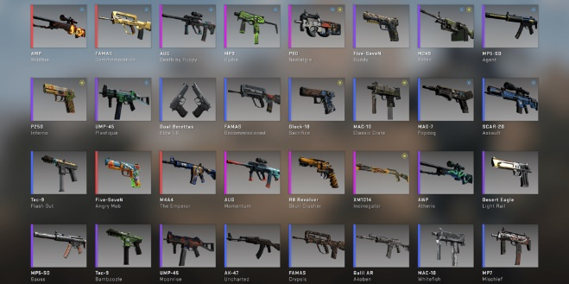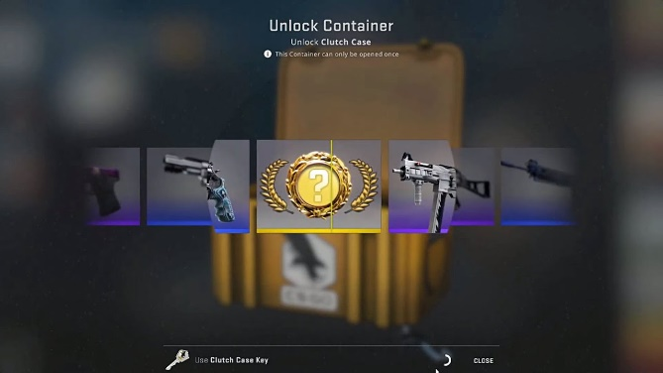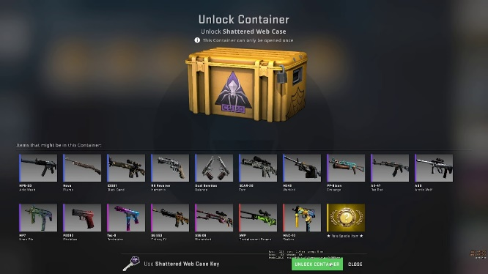

Fig ii: The screen within CS:GO when “rolling” a case which will be recreated in minimalist fashion

Fig i: The case opening screen used within CS:GO  
which will be recreated in minimalist fashion on the site

Fig iii: The inventory menu within CS:GO which will be recreated in minimalist fashion on the site

# Social and Ethical factors

## Ease of use

To best accommodate both players of “CS:GO” and new users who may have never interacted with a “case opening” system the simulation will have to be intuitive, have a simple UI and offer informative tooltips to the user. These goals can be easily achieved within the system by designing a simple UI from the beginning, integrating a tooltip system within each section of the software and accommodate a design that is akin to the case opening system within “CS:GO”

## Ergonomics

As the system is designed to be a simulation with sessions that may end up lasting an extended period of time, depending on the user’s luck, the user-experience must be comfortable and easy to use for long sessions and provide the ability to close the browser window and pick up where you left off. This can be achieved through simplicity in the site’s design, taking parallels from “CS:GO” for familiarity, and an integration of a save function within the browser local storage. The user should not be required to be jumping from page to page, preferably the simulation would operate within a single HTML page and utilise DIVs when altering what is on screen. Important information to the user such as current balance should be displayed along a top bar which is visible at all times.

## Inclusivity

The system has the possibility to be used by any range of user, who may experience disadvantages navigating the web. The site must cater for this variable through a design which is inclusive towards visually impaired user and religious users who may find certain material offensive. During the testing phase the site is to be evaluated by a range of users to identify such issues, however, to best prevent issues with inclusivity, the design process must focus on specific aspects such as:

* The font size, appearing in a readable size (at least 14pt) and contrasting strongly with the background
* Website elements must be appropriately spaced on the page
* Interactive elements such as buttons should appear as a standout on the page through use of contrasting colours
* The colour scheme of the site must be inclusive to those with colour blindness, utilising contrasting responsive elements which are a standout on the page

## Availability

The availability of the case opening system depends upon the availability of the CSGO Backpack API server, as the price data is provided via their database which is update every 8 hours. If a user has previously used the site the price data from their last session will be saved within their browser and this issue would not affect their usage of the software, however their prices would not be accurate.

To best manage this potential issue the site will include a timestamp when saving the CS:GO backpack API database to the browser, allowing the site to detect if the current price data is inaccurate and either allow the user to refresh the database if it is available or continue usage with inaccurate data if the API is not available.

## Security and Privacy

The website does not pose any security or privacy risks as no confidential information is involved. At most the utilised API could be hijacked and when the database is pulled the desired data is not provided, preventing the site from working properly. However, as the API pulls its information from the Steam Marketplace, which is owned by a multi-billion-dollar company, the odds of such a risk are minimal to a point no required methods are needed to be put in place.

## Copyright Issues

As the site mainly relies on an externally created database from CS:GO Backpack’s API which itself scrapes data from the official Steam Marketplace an issue arises as to the usage of this data. As the nature of the API is free-to-use yet not open source the author must be credited within the documentation, code and visibly on the site. As the API uses the Steam Marketplace’s data and images from CS:GO are used within the software, their parent company Valve Software must be credited visibly on the site. These credits would appear on a footer available on all pages of the site and claim no affiliation or ownership of the original copyright owner’s content.

# Gantt Chart

**Complete Interactive Gantt Chart included as an excel file with the project proposal as well on the** [**project GitHub**](https://github.com/oscian44/Major-Project-2022_Case_Opening) **(entire Gantt Chart in screenshot form shown below)**

# Bibliography

Scott-Jones, R. (2017). Here are CS:GO’s loot box odds. Retrieved 21 February 2022, from <https://www.pcgamesn.com/counter-strike-global-offensive/csgo-case-odds>

CSGO Database. (2022). Retrieved 21 February 2022, from <https://www.csgodatabase.com/>

CS:GO Backpack API. (2022). Retrieved 21 February 2022, from <https://csgobackpack.net/api/>